**Synopsis**

The basic synopsis of the film is a spider-man fan film that targets Spider-Man going through a rough patch and doubting himself as a hero. The synopsis written by the director Igor Santos perfectly explains the films synopsis in a more in depth way “*Peter Parker can't decide on what he wants to do in his life, he can be a photographer for the daily bugle, or stay as Spiderman. But New York is safe, he hasn't fought any villains in months, Peter simply can't keep it up. He decides to leave the spiderman Lifestyle and join the daily bugle. Peter Parker loves his new job forgetting Spiderman ever existed. Villains catch the news that spiderman has gone on holiday, bringing villains together to destroy New York. Shocker hearing the news has a new prototype weapon to attack New York. Shocker now attacks New York making Peter Parker return to the Spiderman Lifestyle and try and save New York. Shocker and Spiderman had an incredible battle however Spiderman was defeated. New York is now in the hands of the villains and the civilians trust was ripped away from Spiderman. Will New York be saved? Who will the civilians turn to for safety?”* This is the second synopsis written by Igor Santos, the first was very ambitious and was scrapped, the new synopsis above is still very ambitious but reasonable in the short time frame we have. The issue of running out of time to record will always be very prevalent, my last FMP in 2022 was a failure due to me and Ben Kingaby running out of time to film and to compensate we had to turn it into a trailer. Turning this idea into a trailer or a small teaser could work in our favour as we would have more time to work on the VFX which will always lack behind as this is extremely new to the whole group.

**Target audience**

The target audience for marvel films aims for young teenagers to young adults. The PG rating of all Spider-Man films is PG13, and so isn’t intended for younger children under the age of 13. As shown by Source A from Morning Consult, the most prevalent marvel fan is Millennials.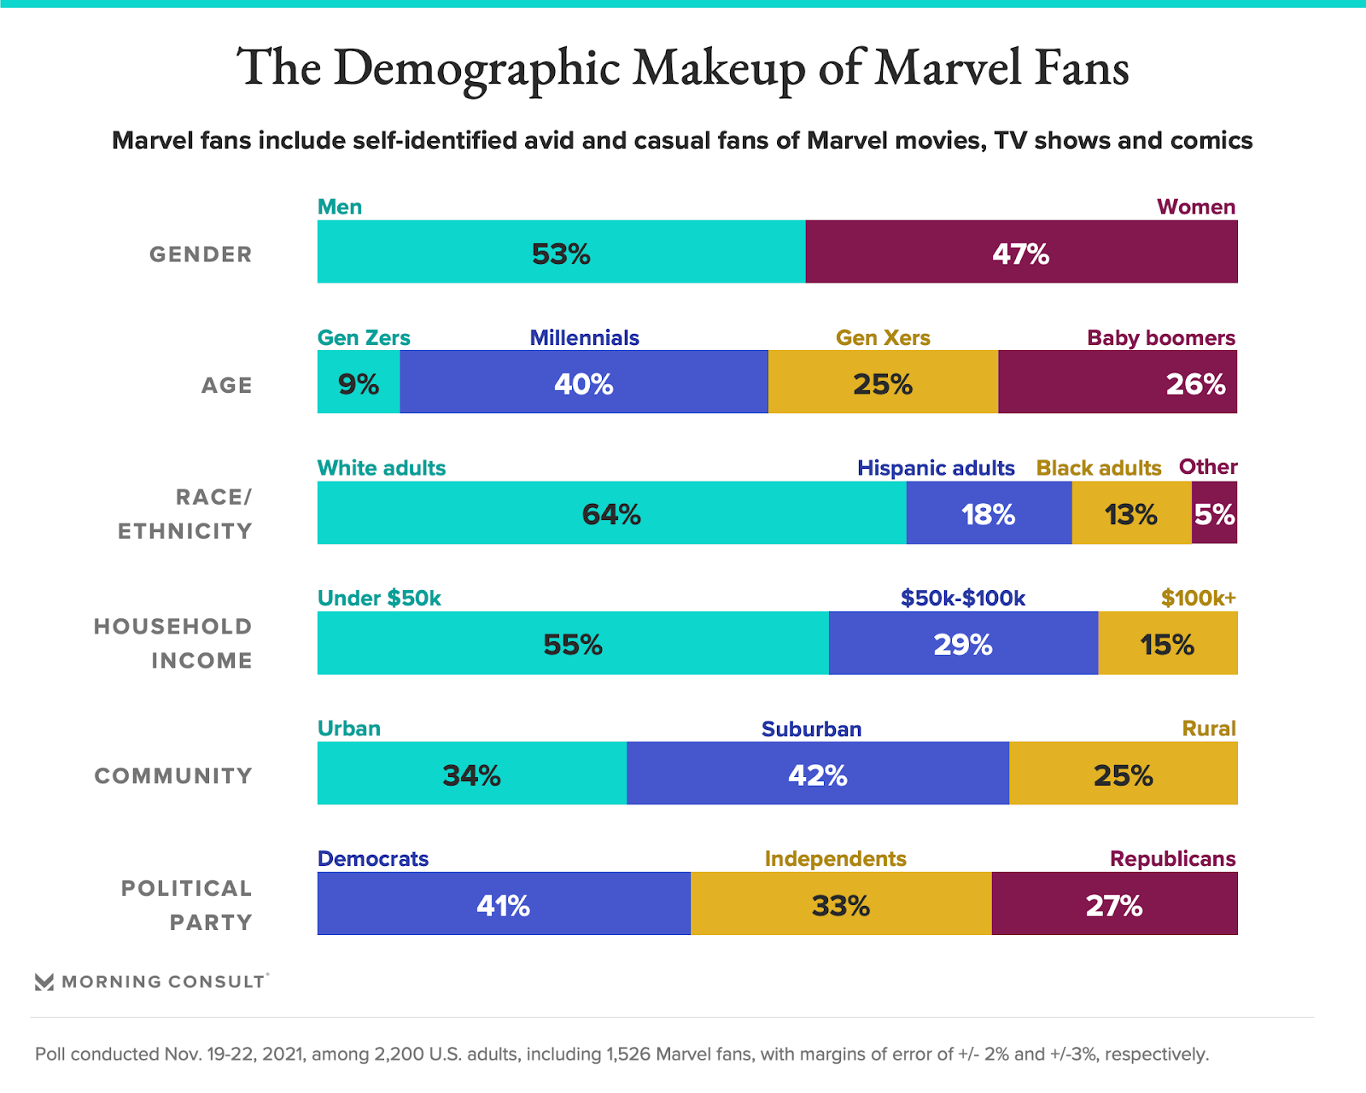 “Fans of Marvel comics, films or TV shows are most likely to be millennials (40 percent). Roughly one-quarter of the Marvel fan base are baby boomers and Gen Xers, while Gen Zers account for just 9 percent of Marvel fans.” The Millennial age group is 25-40 and makes up 40% of the MCU’s viewers. While the Spider-Man films are only a small number of the Marvel films, they all share the same PG rating and superhero themes. Whilst the age demographic that watches the most is millennials I believe that number will be inflated due to the possibilities of Millennials being able to discuss with other Marvel movie fans either online or in person at conventions. Using the research from The Morning Consultant, I believe we should aim for the fan film to be targeted for ages 16-40 as this target audience is shown to be most interested in this film out of any other demographic. The target demographic being 16-40 also matches the fan film theme, as it's only a fan film and wouldn't be widely shown, it would be for the fans of Marvel and Spider-Man which is most communicated about in the age range of 16-40. I believe the PG rating of 13 would fit the film as I don’t believe going any higher would improve viewership or allow any themes that would improve the film in any sense. To see if my research had merit, I conducted a survey to get the public's opinion on Spider-mans target demographic and if any changes should be made to it. In total I got 18 responses with the ages ranging from 17-31 but a high majority 19 which is slightly below the target demographic of Marvel.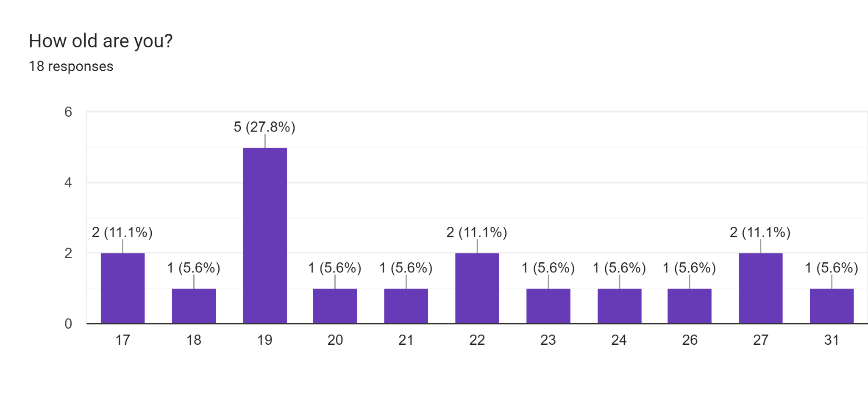

For the first question I asked what Spider-Man films the responders have watched. The options ranged from the originals (Spider-Man 1-3) and the most recent Spider-Man: No Way Home. It’s best to group the films into 3 categories; The original trilogy of Spider-Man 1-3, The Amazing Spider-Man 1 and 2, And the Marvel Cinematic Universe rendition of Spider-Man: Homecoming, Spider-Man: Far From Home, And Spider-Man: No Way Home. The odd one out is Spider-Man:Into The Spider-Verse. Spider-Man: Into The Spider-Verse is the odd one out as it is the only animated film on this list and naturally appeals to a younger audience. It follows a completely different main character with Miles Morales as Spider-Man instead of the classic Peter Parker.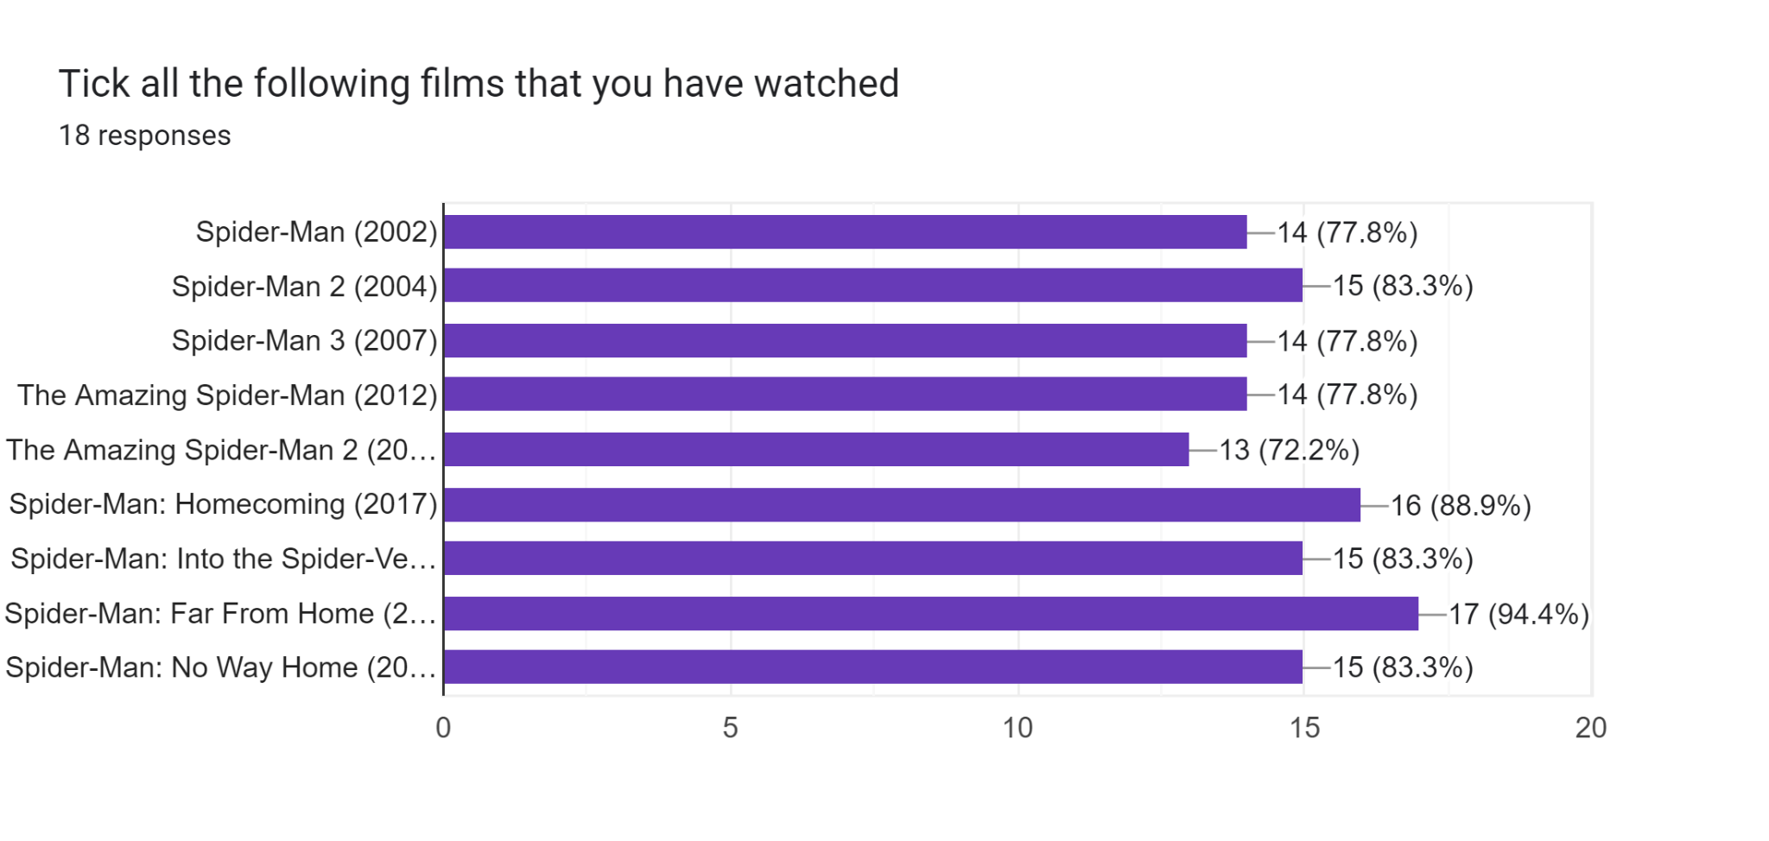

After tallying up the individual responses the trend that I have found is that 60% of the millennial age group who answered have watched all Spider-Man films listed above. Whilst 57% of the Gen Z have watched all Spider-Man films. This shows that the millennial age group is slightly more likely to have watched the Spider-Man films in general but I think to pinpoint whether which group prefers certain films I would need more concrete data with more responses.

For the most important question I asked the audience “The age rating of Spider-Man films is PG13. Do you think that a Spider-Man film that appealed to a more mature audience would be successful?” The responses I got were interesting. 38% of the audience thought that a mature film would be successful, 44% of the audience thought it would not be successful and 16% had no opinion. The millennials were split 50/50 on No, it wouldn't be successful and the other 50% had no opinion. I believe the reason the millennials don’t believe it would be successful is because of nostalgia, I believe that nostalgia makes the millennials believe that a child focused film would be more enjoyable as it would take them back to when they first watched Spider-Man as a child and they can now watch that and feel like a child again.

**Camera and lighting**

Camera is my main role alongside editor and I believe both coincide with each other in a way that I know how the shots are going to be edited and that I have an idea of the final vision and final product. This also makes me realistic in how we shoot the shots as I know what can and can’t be done in the premiere to make the shot look good.

We are planning on using 2 cameras for some of the shots to get double the footage in the same amount of time. I believe doing this will result in a more professional looking film as in marvel films, there are hundreds of shots that are used per film. In spider-man: No Way Home there are 213120 frames (No definite data was found for this so to find out the frames I used Movie length in seconds x 24 which is the standard frame rate for cinematic productions). To record a production that isn’t too stiff it would require multiple scenes and camera angles so a second camera could be used. There are a few problems with using 2 cameras at once, this includes; needing 2 camera operators to record, the cameras can’t see each other, double the setup time and that both cameras need to have a well lit shot that is of equal quality to the other. I believe the setup time would be worth it as recording more shots would equate to more time than setting up a second camera and tripod. Having the cameras not see each other is tricky, but as long as we place them strategically then we should be able to keep them out of frame. While the lighting being off for one of the cameras could be a problem, it shouldn’t be a problem for our production as there are quite a few shots that would be in close proximity of the target so the cameras inherently would be close together, we will have to be careful on where the lights are facing as to not have them only visible to one camera at a time but it should be fine otherwise.

For shot types, a mix of wide shots and close ups will be used to orchestrate how we want the audience to perceive a character or area. A wide shot portrays the area around a target as vast and making the target seem small, this could be used as a way to portray the target as weak and incapable and helpful in making Spider-man look weak to begin with but then with time growing in strength.

Spider-Man: Into the Spider Verse gives a great inspiration as to how I want to use the camera to show Spider-man's strengths. In the top image, Miles Morales is shown as not lining up with the suit, he is looking up at the suit in a way that makes the audience seem like he isn’t as powerful as spider-man yet to symbolise he isn’t ready. When the camera is angled upwards it shows that the target is grand and something to either aspire to be or be terrified of (if it was showing a villain). In the second image, Miles is shown to be at the same level as the suit, this symbolises that he is ready and has the same power as the original Spider-man. This concept perfectly shows how Miles has grown and become stronger than before.

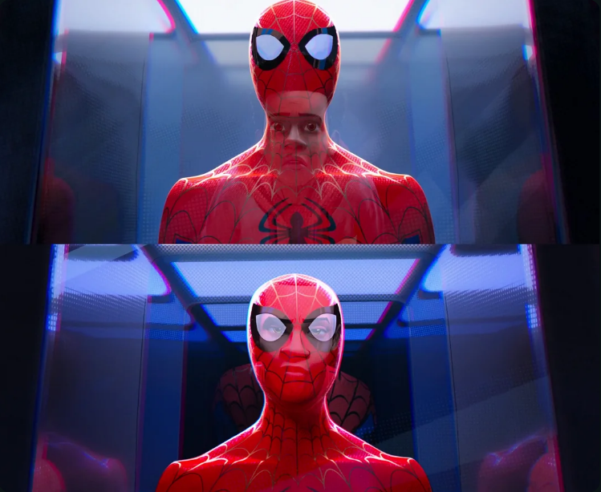

For lighting I wish to portray character emotion with the lighting and colour to make the audience feel certain ways.”In film, blue is the color of coldness, isolation, cerebral, melancholy, passivity, calm, faith, spirituality, loyalty, tranquility, harmony, unity, trust, and water.” I wish to use the colour blue a considerable amount as for a large part of this film Spider-Man isn’t sure of who he is and what he wants to become. When Spider-Man decides he will fight shocker I could use colour to convey confidence. Using red shows that violence is coming and Spider-Man is prepared *“Red is a color of extremes. In film, red is the color of love, passion, excitement, desire, violence, blood, danger, anger, fire, war, heat, and rage.”*

**VFX And the making of Spider-Man**

The VFX of Spider-Man: Villains Rise is the hardest part of the whole film. Whilst the idea of Spider-Man is simple, the way of creating the effects is tricky. The way Marvel creates the iconic swinging is by having Spider-Man is by using a crane and attaching the actor to it with a cable to mimic the swing, the cable is then turned into a web in post. Due to the limitations we have, we cannot create swinging the same way as Marvel. The few solutions we could use are to green screen Spider-Man swinging once then layer that on top of any clip we need to, minimally use swinging by having Spider-Man just jump off small ledges and add the web in post to simulate the swinging and the final way of simulating swinging is to create the animations in blender, a 3d modelling and animation program. The green screen technique I believe would look tacky and the green screen swing would have to be perfect to layer on top and have it key properly. Blender is a difficult software, myself and Igor Santos tried our hardest in a short time span to learn the software well enough to simulate Spider-Man swinging but we learnt that it would take too long to create a decent product. The only option we have is to leave swinging out of the film as much as possible and when we do add swinging, adding the web in post. For the web slingers during combat or just Spider-Man attaching his bag somewhere, it is best for us to add the webs in post.

References:

Alyssa Meyers, S.S. (2022) *Is gen Z too cool for marvel? Just 9% of Marvel fans identify as part of the generation*, *Morning Consult*. Available at: <https://morningconsult.com/2021/12/06/is-gen-z-too-cool-for-marvel/>.

Rothstein, A. (2020) *Color theory in film: A video producer’s guide*, *IPR*. Available at: <https://www.ipr.edu/blogs/digital-video-and-media-production/color-theory-in-film-a-video-producers-guide/#:~:text=Color%20can%20set%20the%20overall,of%20a%20character%20or%20story>.