**The original idea:**

My original idea for the FMP was to create a music video that mimicked that of the Kid Laroi - I wish [The Kid LAROI - I WISH (Official Video)](https://youtu.be/n79N2Vk2Y48). I wanted to recreate this as at the time I was very intrigued by his music and inspired to work around it. I believe that when you find a project you want to work on the final product will end up substantially better overall as it wouldn't feel like a chore to do so, so even though the music video was not the most technically advanced I believed that I would have made a brilliant product using it. 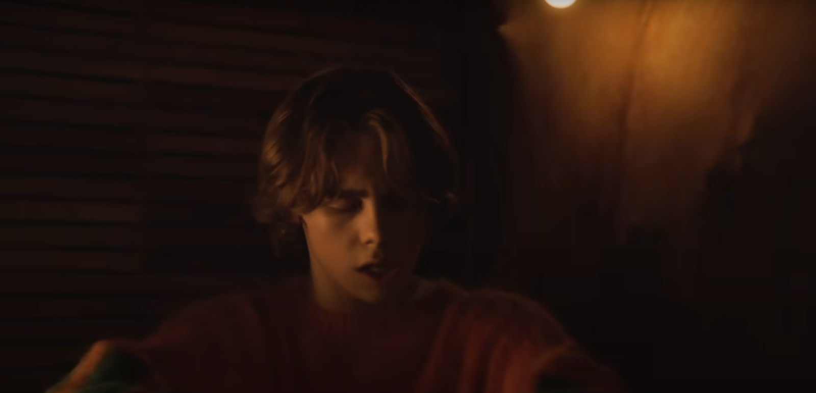

I was desperate to recreate this scene here as I believed that this would be difficult to recreate and show some great editing and camera skills. The set looks amazing but basic, it's a flashing light in a dark room with a curtain that is being pushed on which could easily be recreated. I believe that I could have a smooth transition by using dip to black in between the light being turned off to smooth out the transitions of him turning into a skeleton.

Another scene I wanted to recreate was this shot with the well.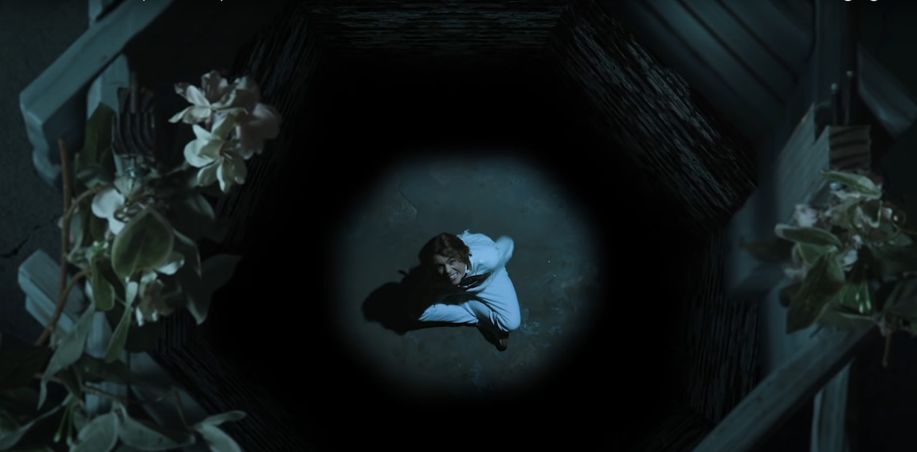

It features a shell of a well and someone sitting at the bottom. While this would have been trickier, I believe that it shows a large amount of skill and would be something different than what I am used to working on. I had the idea to place a tripod high up and have a small well shape underneath it, not on the floor but close to it so we can shrink it down and have the illusion of the well being larger than it is.

I was planning on directing and editing this project and finding crew to be lighting, camera and producer. This was all going ahead until Igor Santos showed me his Spider-Man: Villains Rise project and at the time I was having difficulty getting my project going so I agreed to work with him on Spider-Man: Villains Rise. If I could go back I would have told myself to work on my own project as I was very motivated to work on the music video even if it was by myself and had already come up with ideas, whilst I didn’t dislike working on Spider-Man: Villains Rise I believe that I would have enjoyed working on the Kid Laroi - Wish music video more and subsequently creating a more impressive project with more passion behind it.

**Spider-Man: Villains Rise**

When I first started Spider-Man: Villains Rise I researched heavily into Spider-Man fan films. I researched more on the fan film genre that starred spider-man instead of the high budget productions because the fan films where a more attainable goal compared to higher budget films. I watched films by Jesse Scimeca and Scean Bichimer. Both produced Spider-Man fan films.

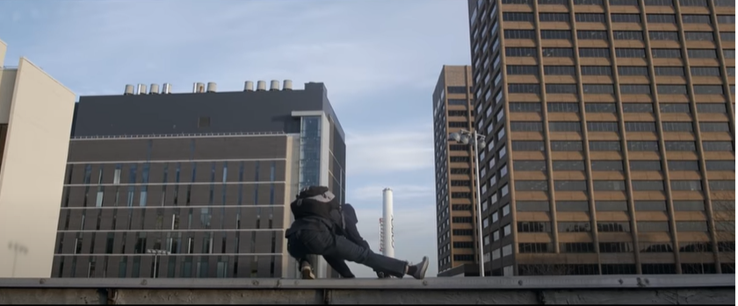

I looked at shots like the one above where they mimicked the effect of Spider-Man being high up by having him stand on a ledge that only had a short drop behind it that the viewer can’t see. We did this ourselves and I believe that it worked out very well and it looked like he was sitting at the edge of a building.

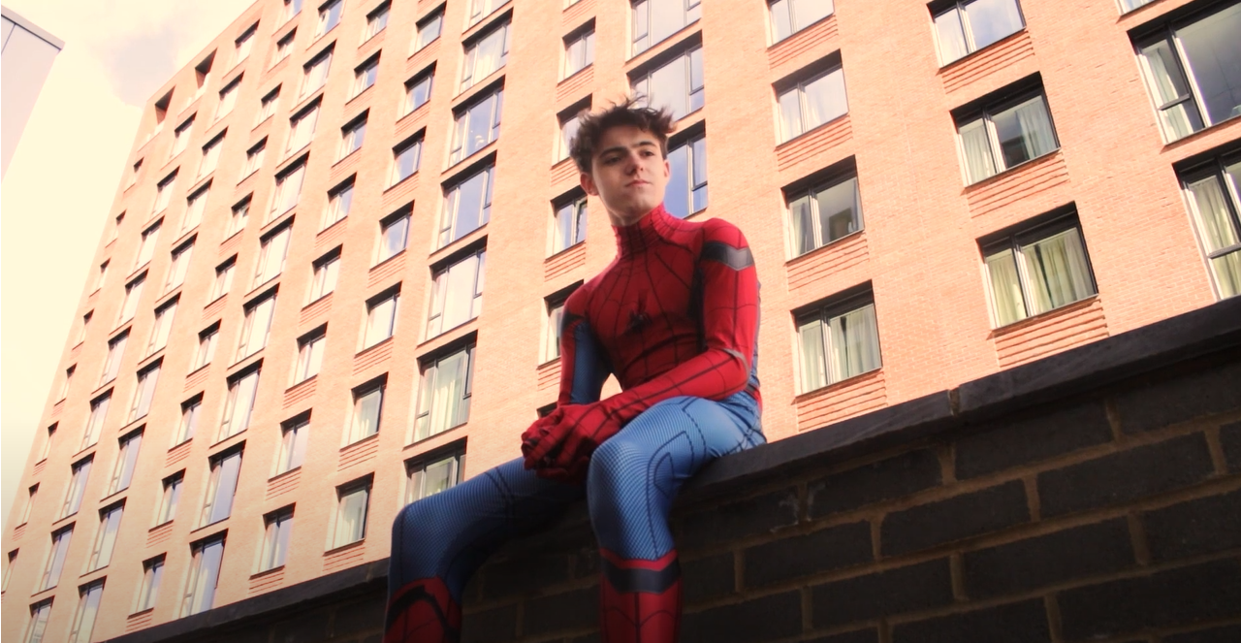

If I was to redo this project, I would have added more scenes that try to mimic Spider-Mans elevation or speed as I feel like we didn’t add enough to show this, and Spider-Man doesn’t seem special because of it. This would be one of the struggles of filming a Spider-Man themed film, without the high budget it makes it incredibly difficult to mimic the height and speed of Spider-Man. Another problem with the height and speed was making Spider-Man swing. We had a couple options; the first option was having Spider-Man swing once in front of a green screen the using that every time we had to make him swing. This wouldn’t be a viable option in the end as even getting that one swing is difficult to record and in the end the swing would look tacky and wouldn’t always match the shots we wanted to film. The second option was to have Spider-Man swing off camera and just have him run out and jump for the swing, this would be difficult to film in certain locations where we may have wanted him to swing of certain high up buildings but was a viable option. The third option we had was to use Blender, a 3D modeling and animation program which could have created an animation of Spider-Man doing whatever we wanted, this was the option we were siding with as it had the opportunity to look the best. We ran into some issues though when both me and Igor could not figure out the program in the limited time we had, Blender is a very complex program and even getting the Spider-Man model is difficult, to animate Spider-Man and give him realistic physics would have been an even bigger challenge that in the short time span we had to learn would not have looked good and would have ended up with a tacky looking product. The last option we had was to never have Spider-Man swing but this would have made Spider-Man seem less powerful and ruin the atmosphere of Spider-Man. We opted to go for the second option but use it rarely, I had hoped to have used it more, but we only ended up having one scene where he swung which was after he stuck his backpack to a tree with a web.

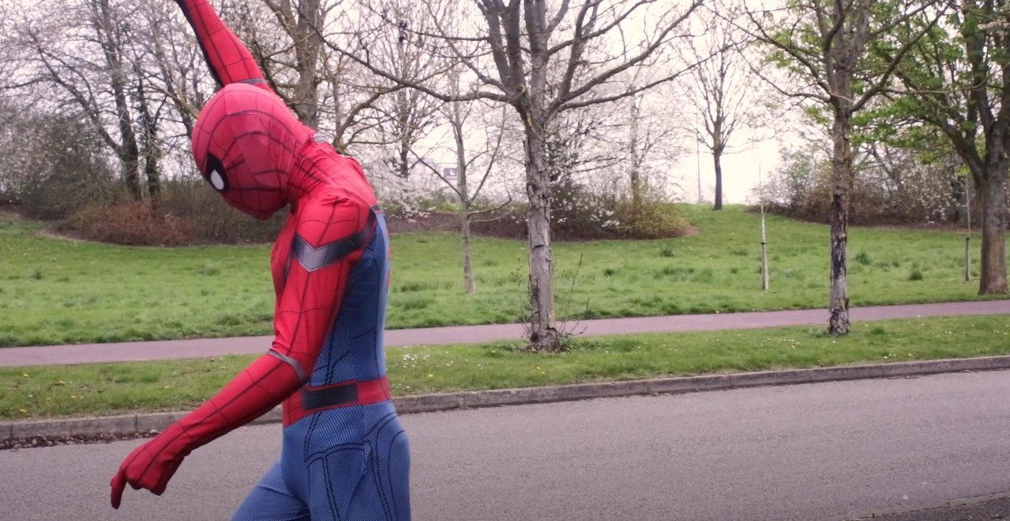

For this clip we just had Spider-Man run out of shot while mimicking the swinging action and it turned out quite convincing after the sound effects had been added. I believe the final effect was effective and convincing but could have been more professional looking if we had more of the web shown in frame and actual swinging instead of running but I do not think there is a feasible way of making the swinging look more realistic that we could have created in the time we had.

**Stunt Choreography**

We ran into some issues with the stunt choreography during pre-production. No one in the group has ever done any stunt choreography before so we were going in blind and to learn everything ourselves to begin with. Igor and Noah researched how to choreograph a fight whilst I was researching how to record the fight. Something I saw immediately was that filming a fight can be very difficult as the camera must be behind the target that is getting hit with a punch or kick, otherwise it will be obvious that there was no contact made between the 2 targets. Another way to avoid seeing the non-contact between the 2 targets is by having the camera move frequently but this would require a lot more coordination and steadiness. I do not have a steady hand and cutting between shots would not be as smooth as we can’t keep the camera in the same position for transitions. I opted to go for wide shots for the fight choreography as Igor reccomended that I did during the practicing stages of choreography and when it came to the shotlist we chose wide shots to show the crowd that was watching the fight happen as well as letting the wideness of the shot cover up the non-contact of it all. We had a hiccup where Noah was injured during a practice session for the stunt choreography, this meant we couldn’t practice the choreography for a week or 2 afterwards and it made it so we had to think more about how safe the production was and where we were filming as even though there was a safety mat, Noah still got injured. If I ever do another production that involves stunt choreography, I plan on having more preparations in place to prevent injury, including softer mats and practice with fake hits before choreography starts. I would also have shot the film differently and gone for more dynamic and flowing shots by having the camera move in time with the punches as the wide shots are all very static and having the camera not move makes the fight seem slow and static.

**Production**

We started production in Igors own bedroom in Bradville, this turned out to be problematic because we found out very early into production that the bedroom was just too small for the crew to fit in and wasn’t suitable for filming, we had filmed some shots for the project proposal but after that we decided to move production of the bedroom scenes over to the MK college bedroom facility. This worked heavily in our favor as it meant we had room to work in and it was on campus, so it was easiest for us all to get to. Although we had picked a better location for filming, the schedule wasn’t perfect. We kept switching locations and we didn’t film the bedroom scenes all in 1 day. This meant that every week we would be switching from the city to the bedroom and keep switching every week which slowed down production greatly, the reason we did this was because the room was only available on Fridays at a certain time so most often we had to work around that schedule which made the project a bit slower and more choppy to film. In future I hope to be able to find a different space that we could book out for 1 or 2 days so we can film all the scenes in that location in that time instead of going to different locations one by one.

One of the scenes I would like to talk about in my evaluation is the mirror scene. I came up with this scene myself when we started filming in the bathroom and I wanted it to reflect how Spider-Man feels about himself and that he feels like he is trapped as Spider-Man, at that moment in the film he is going through a rough time with the daily bugle saying he is useless and so he is torn on whether he should keep going as Spider-Man or not. The first time we recorded this scene, the camera had moved slightly, and I accidentally left auto exposure on, so the shots looked different in the minutes that passed between shots and it was obvious that the lighting had changed. We re-shot the scene but this time I made sure no one went near the camera and the auto exposure was off. It turned out to be a great looking shot and it perfectly showed Spider-Mans emotions at the time after I turned off auto exposure and made sure the camera was still

.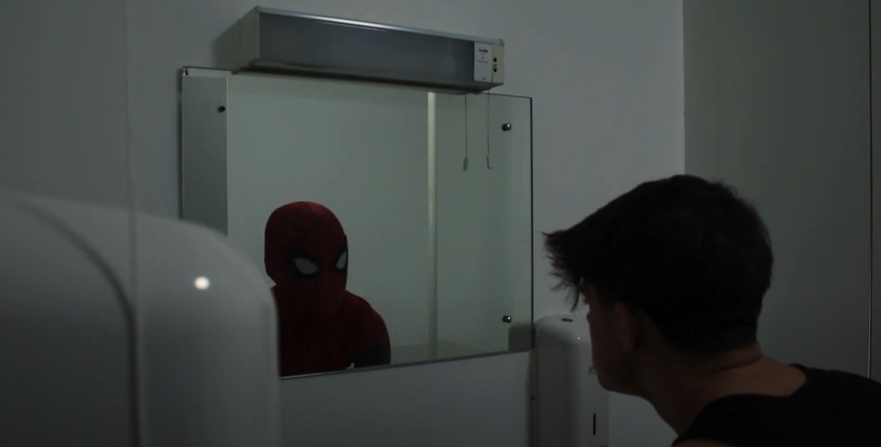

Another scene that I love was the scene where Spider-Man was looking down on his suit, even though I did not edit the whole film I hope that this shows that he isn’t ready to fight Spider-Man I researched this from the Marvel film: Spider-Man: Into The Spider-Verse where Miles Morales is shows as lower than the suit showing that he wasn’t ready to be Spider-Man, but then later in the film it shows Miles Morales as head to head. This shows that he was ready for the fight and that he was prepared to be Spider-Man. I had planned to do the same thing in our film, but the issue I had was that I had to cut the edit off before I could get to show both the scenes. In future I hope to have more time to edit and so use all the shots, this just came down to bad planning and my editing style being too slow. 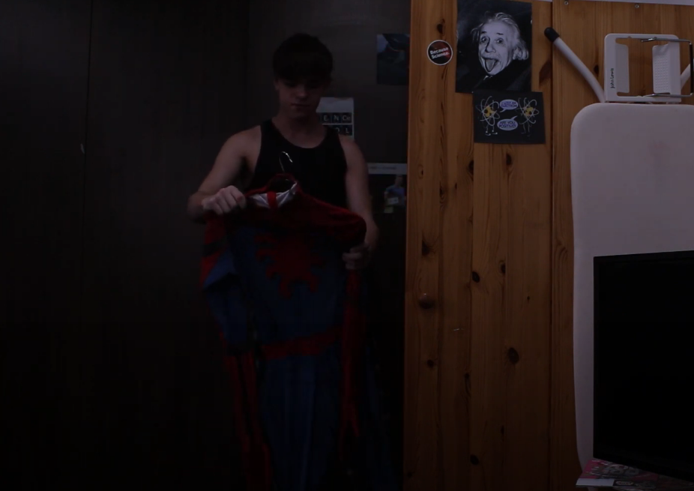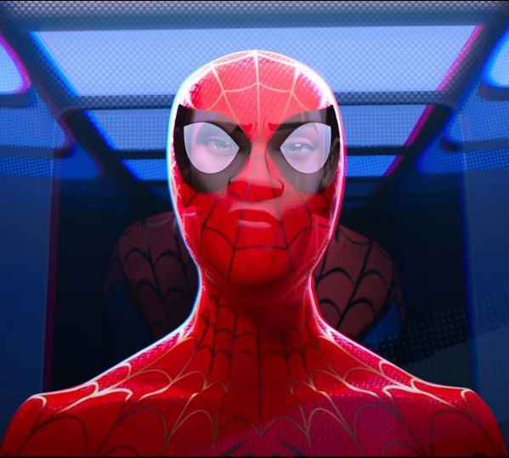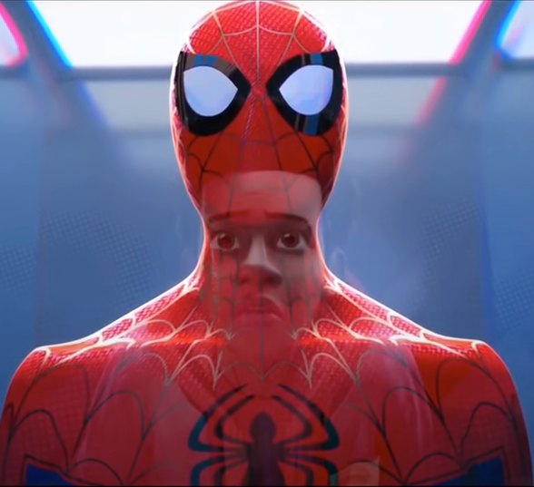

An issue we had with production was that we couldn’t get equipment during the break as other groups had to use it and we couldn’t agree on a time to get it back. This meant for the 2 weeks easter holiday we couldn’t film except for 1 day which I wasn’t able to attend to. Another issue was the inefficiency of filming during the fight day. We filmed the fight scenes all in one day, but that day was extremely slow and disorganized. It was incredibly difficult having Igor be director and the main actor as it meant he could not direct and act at the same time. If I could redo the project, I would have pushed more for the group to find an actor for Spider-Man and even the Shocker, so we don’t have crew filling in and not able to do their roles to the best of their ability.

Production in conclusion was slow and inefficient and we had multiple issues including equipment shortages, actors dropping out and slow production times. We could have avoided these issues quite easily by being more prepared for problems, the project has always been very ambitious and difficult and so when preparing for filming we always planned for the best-case scenario. In any projects I do forward I will be going off the idea of preparing for the worst and hoping for the best as to ensure everything always gets done and the expectations are never too high.

**Post Poduction**

Postproduction was a challenge for me. I had only a few days to edit the film and was struggling to complete it. I had multiple issues including; the large amount of footage to sort through, missing footage, my original project being deleted and then running out time.

The footage we had captured was always uploaded to One drive but was never named or sorted unless it was a specifically important shot. In hindsight this was not a good idea as it meant very quickly footage was becoming difficult to find and some footage would go “missing”. Next time I am involved in a project where I am behind the camera, I will try my best to provide the SD cards and make sure that all SD cards are uploaded straight after filming and done by myself.

Due to the slow filming times of the production, I found that I was running quickly out of time to edit the final film. This led to some effects not being finished or being replaced with different effects that were easier. One way I changed the effect to be easier was by making the last 2-3 minutes of the film greyscale. I wasn’t planning on doing this until very late into the project where I was running out of time to do color correction, I decided that the easiest way to go about this was to make the greyscale fade in with Spider-Man getting beaten down to show him losing his motivation until its fully beaten out of him by the end of the fight. This masked the lack of color correction and took away possibly hours of editing and shortened it to a mere few minutes. Another effect that had to be changed was the shockers gauntlets, I was planning on using the saber plugin to make some electricity effects pulse through Spider-Man when he was punched but I was running out of time so I had to settle for a shaking effect, this was something I regret and wish I spent more time on because I believe it made shocker seem powerless and not as “Super Villain” like as he didn’t seem to have any powers. The last way I made editing easier was by shortening the film and cutting the last fight, I tried to cut the film at a moment that may be plausible to be picked up for a second film and I believe I chose the best moment to do so. If I could go back, I would have liked to have started work on the edit sooner or even shorten the project a bit more to have more time editing instead of focusing on the number of scenes, this tunnel vision on the number of scenes I believe was the main downfall of the film, Next time I am in a project I will try to be more realistic with the length and difficulty of the film.

**Peer Feedback**

I asked an acquaintance to review the film and here is what they had to say: *“the panoramic shot of the city with the news reporter speaking over it implies that this issue is a big city wide issue that not just anyone can fix spiderman is back in his dark and gloomy room conveying all of the same emotions as described before whilst he is getting ready to suit back up which contradicts the mood in the room showing a duality between peter parker and spiderman the fight scene shows a villain who has recently risen to fame face off against spiderman spiderman is overconfident because he has never heard of this villain before and underestimates his opponent this causes spidermans efforts to stop this villain to be futile the villain then makes a mockery of spiderman and publically humilates him to fully demoralise spiderman the screen turns to greyscale showing a lack of all positive emotions and making it clear that these are now tough times for peter peter leaving the suit in the street and walking away shows that pter has turned over a new leaf in his life, for better or for worse, and will begin his new journey as a new him” - Mathew Wright*  I asked once he had watched the film and overall he thought the film was good but lacking in acting overall and the pacing seemed rushed. I must agree with him on both points, I believe that if we had gotten trained actors for the roles of Spider-Man and the Shocker the acting could have been significantly improved but this would pose difficult as finding actors is quite tricky. In future projects I hope to find actors before filming and only using the crew as a backup. For the pacing I believe that it was fast, and the pacing was off, this will be because we had to cut the film short as it was too ambitious and too long to film. In future we need to discuss what is reasonable to film in the time frame we had to avoid bad pacing in the final product

**In conclusion**

In conclusion, I believe the film was not horrible but had its drawbacks. There were certainly multiple drawbacks that naturally would have come with the production but quite a few problems could have been avoided and in future I have taken away what to change. Key points to change in future are more safety measures in place, realistic filming schedules, more efficient filming days and longer times to edit. I believe that the project was successful in creating a fan film, but compared to the original vision it was not successful but that would be expected as the original product was very ambitious. I am hoping that the project is worthy of a merit as I was aiming to at least get a merit so I can get into my universities of choice, I believe I may have succeeded in this with the research I did and the camera skills I have shown.